NETWORK CONFIGURATION (KDOT)

Updated: 10/1/2025
Description. This work shall consist of configuring, testing and provisioning a fully operational Ethernet Local Area Network (LAN), which provides communication with remote traffic control field devices from the Kane County Division of Transportation (KDOT) Arterial Operations Center (AOC). This work also consists of coordination with KDOT to test and integrate the new devices onto KDOT’s network monitoring software, SNMPc, KDOT’s Advanced Traffic Management System (ATMS), TransSuite, and Video Wall management system, Christie Phoenix, as appropriate.

These devices include Layer II Datalink Switch, Layer III (Network) Switch, traffic signal controllers, loop detectors, Malfunction Management Units (MMUs), Uninterruptable Power Supply (UPS) units, Video Detection Systems, Microwave/Radar detection systems, CCTV (PTZ) cameras, and other specified Intelligent Transportation System (ITS) field devices as shown on the plans and having Ethernet connectivity options. These ITS devices may include, but are not limited to, web power switches as shown on the plans.
CONSTRUCTION REQUIREMENTS

The Contractor shall coordinate work required for integration with KDOT TSMO and NOM consultants for testing and integration. The work shall include configuring Ethernet switches and any other device with network connectivity, assigning IP addresses to field devices based on KDOT Traffic staff input and standards, troubleshooting and submitting documentation to KDOT Traffic staff of final configurations and the verified testing of communication to each device from the network. Configuring switches with dedicated Virtual Local Area Network (VLAN) and port assignments to match existing network switch settings shall also be included.

The contractor shall also coordinate final connection to the existing system network with KDOT Traffic Operations. The contractor shall coordinate with KDOT Traffic Operations, the KDOT NOM consultant, and the KDOT TSMO consultant to coordinate programming requirements for the final network configurations prior to final turnover. The final engineering drawing(s) shall be submitted with the contractors as-built record drawings to the KDOT Traffic Operations Engineer which inventories all fiber optic cable/tube/fiber terminations and splicing and which shall document all IP configurations for each device which has been brought online into the KDOT network.

EXAMPLE ENGINEERING DRAWING
(to document Cable/Tube/Fiber terminations and splices, IP addresses and port assignments)
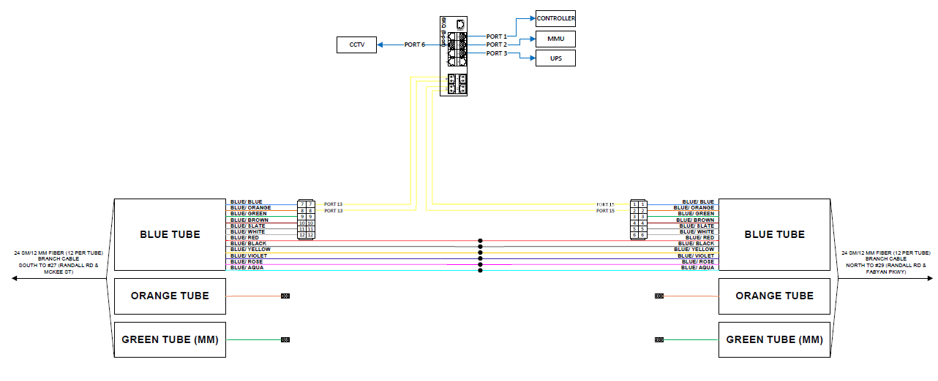

Testing and Integration

The process below shall be completed by the contractor for network, ATMS, and video wall integration.

- Network integration
  - The Contractor shall coordinate with the KDOT NOM consultant to program
and configure layer 2 and/or layer 3 network switches. Program VLAN’s, IP addresses, gateways, and subnets as necessary. KDOT NOM consultant will provide the Contractor network IP’s, VLAN’s, Gateway’s and Subnets for all Ethernet devices to be installed on the KDOT network and integrated into the various KDOT systems. Contractor shall be responsible to program and install all Ethernet enabled devices such as signal controllers, PTZ cameras, detectors, MMU, UPS, etc.

  - The contractor shall coordinate with KDOTs NOM consultant once the devices are installed in the field to begin testing and integration of the devices into the SNMPc network monitoring software.
  - The NOM consultant will add the devices to the SNMPc software and begin testing to verify that the devices are configured correctly to communicate on the network.
  - Once testing completes the NOM consultant will send written verification to confirm that the devices are online and are appropriately communicating on the network.
- TransSuite ATMS Integration
  - The contractor shall coordinate with KDOT’s TSMO consultant to add and configure any controllers, controller databases, and system detectors after installation is complete in the field.
  - The TSMO consultant will add and configure any PTZ cameras or other video feed(s) and test Pan, Tilt, and Zoom functionality within TransSuite.
  - Once integration is completed the TSMO consultant will send written verification to confirm that the devices are online and are appropriately communicating on TransSuite.
  - Contact KDOT Engineer for the current KDOT TSMO and NOM consultants’ contact information.

Basis of Payment. This work will be paid for at the contract lump sum price for Network Configuration, which price shall be payment in full for the work described. Acceptance shall be granted after configuration, programming, modifications, integration, testing and fiber splice and termination details have been completed by the Contractor to the satisfaction of the KDOT Traffic Operations Engineer.

